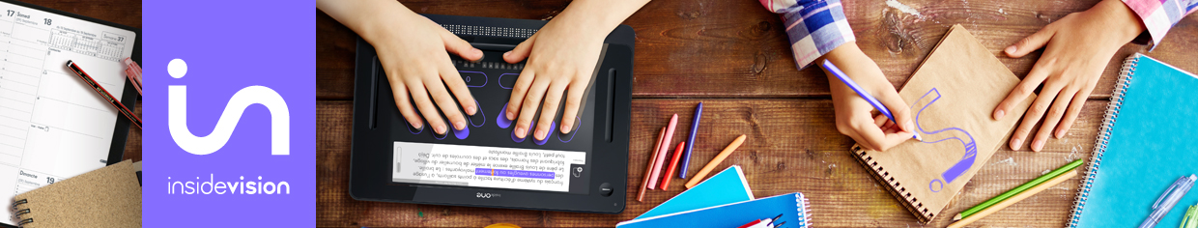

Education

insideONE merging Windows with braille for ultimate independence and productivity

As we all struggle to adapt to life with COVID 19, education today is radically changing the structure, delivery, and technology used to support our children's learning.

Learning is often defined as having the ability and the intelligence to identify, process, and synthesize information that leads to greater knowledge and maturity. Central to that growth, especially facing the challenge of transforming our educational system to one that most effectively utilizes distance learning, is the right technology.
For visually impaired students, this disruption in everyday life and learning methods is far worse. It is so much easier for sighted students to adapt and grasp new ways of receiving information through tablets or other devices.
Many of us, whether we use Braille in our schoolwork, on the job, or to promote independence in the activities of daily living, have always hoped that someday, we might have at our fingertips a powerful and portable integrated Windows Braille computer. And each time a new Braille device is announced, we keep hoping that this time, there will be a tool to promote the ultimate in literacy and self-reliance for our visually impaired students. With the introduction of the insideONE Windows 10 Braille Tablet, we can now deliver on that hoped-for possibility.
The new, cool-feeling Windows 10 tactile tablet with an engraved braille keyboard built into the screen along with an integrated 32-cell braille display will take you anywhere you need to go, literally. This mainstream-looking tablet offers the freedom, and the opportunity, to become proficient in working independently with Braille, speech, and windows applications so that your students can excel and be competitive in performing any educational task or assignment.
Internet, email, Zoom, Chrome, and Dropbox are all there on the desktop, along with the trusted EasyReader most accessible book reading application from Dolphin Systems Ltd. Whether you are a proficient Microsoft Office user or prefer a simpler, faster word processor such as Jarte, both are a click away. For the first time, 21st century computing that comes with integrated Braille is here, growing alongside with students and supported by parents as their children advance in core curriculum knowledge and overall competency.
Upon first holding this device, one rehabilitation professional said:
"The hardware and braille display are pieces of art. The build quality is solid, the aluminum case is a delight to touch and hold, and the Braille is crisp, clear, and a pleasure to read. The movement of the pins is seamless."
Finally, and after so many years, the InsideONE braille computer is what Braille users who need to utilize Windows, along with their classmates, have been waiting for. All in a three-pound, easy-to-carry, and rugged package, protected with a sturdy padded shoulder case. There are no peripherals, no cables, no docking stations, and no braille displays that have to be connected or paired. Truly, this is Braille, and computing power, that leaps into the future.
The InsideONE team brings together a collaboration of two companies, both owned and operated by successful blind innovators, professionals, that you have come to respect and trust: Mystic Access, and GuideLights and Gadgets, backed by the leading technology firm Insidevision, operating both in France and in the U. S. This is not a sighted company making and selling a product for the blind. It is a blindness lead initiative backed by technology that is tailored to fit the needs of children in the 21st century. The InsideONE undertaking is a truly unique collaborative process showing what blind-led training and development organizations backed by technology can bring to the marketplace.
What difference does this make? The tablet will come with both an in-depth machine-specific audio tutorial as well as a comprehensive Windows 10 audio tutorial geared toward Braille users, both created by Mystic Access. It comes with a set of tested blindness-friendly accessible applications. What really distinguishes this tablet is that the InsideONE can instantly display a text translation of any braille typed on the screen for a sighted child and vice versa. The student is empowered to choose the screen reader that does the job best. NVDA is the default screen reader, but JAWS also works interchangeably and seamlessly.
Talk to us about arranging a demonstration so we can show teachers of the visually impaired and administrators many ways that this tablet can be incorporated into the daily activities of your students in the classroom, at home completing assignments, or for entertainment and leisure after work is finished.

Contact us

For more information, please do not hesitate to contact a member of our team.

Mystic Access Team

chris@mysticaccess.com
kim@mysticaccess.com
phone: (716) 543-3323

GuideLights and Gadgets

bscheur@scheur.com
phone: 617-969-7500

Insidevision Inc.

igor.feinberg@insidevision-us.com
phone: 781-799-2971

